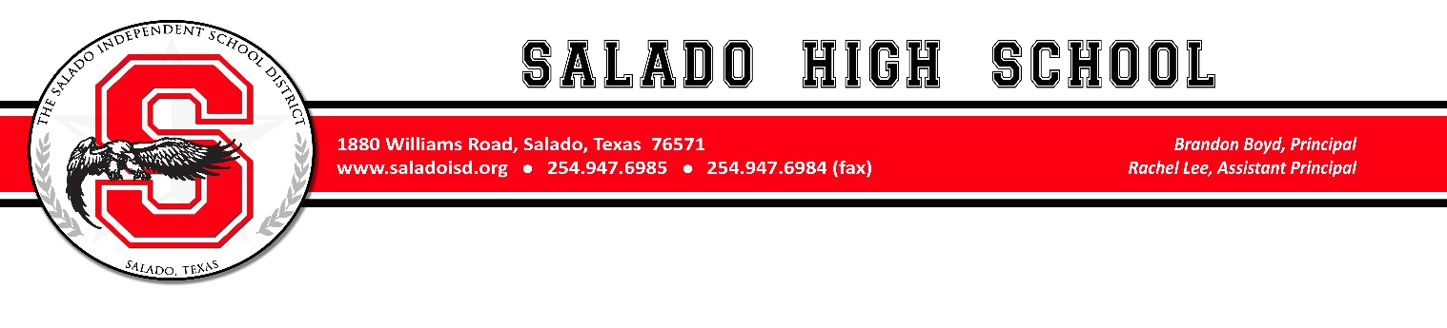

March 27, 2023

Dear Parent or Guardian,

This year Salado High School will be offering Summer School for ACCELERATION. Acceleration is for students that would like to get ahead. This year, we will offer Professional Communications (.5 credit) and Health (.5 credit) in an online platform, and students are required to attend IN PERSON for the full three weeks, or until the courses are completed. Acceleration courses do not impact or calculate into GPA or class rank. Students may choose to take one or two courses, each at a cost of $125.

Acceleration Summer School will begin on Monday, June 5th, and end on Thursday, June 22nd. The exact dates/times are listed below.

Acceleration (Prof Comm/Health): Monday, June 5th - Registration Fees Collected: 12:30pm-1:00pm
Monday – Thursday: June 5,6,7,8: 1:00pm-4:00pm
Monday – Thursday: June 12,13,14,15: 1:00pm-4:00pm
Monday – Thursday: June 19,20,21,22: 1:00pm-4:00pm

Seating is limited for acceleration, so please RSVP to Rachel Lee at rachel.lee@saladoisd.org as soon as possible to reserve a seat for Summer School. Please call if you have any questions at the number below. Fees will be collected on Monday, June 5th, thirty minutes prior to the course start.

Thank you,
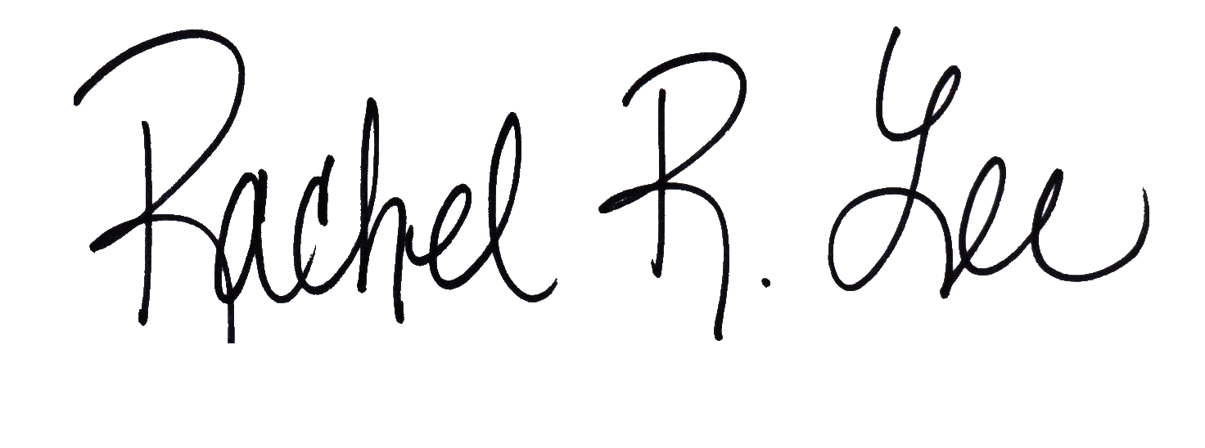
Rachel Lee
Assistant Principal
Salado High School
254.947.6989

